Idea: Positioning of elements affect % pixel unit calculation.
Take three nested div elements,
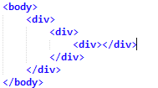
Case 1:Below CSS styling has all three div elements of type position: static,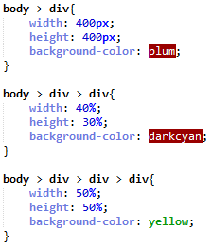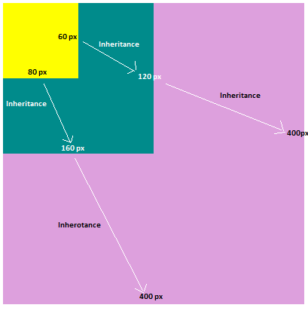

Case 2:
Below CSS styling has only inner most div element of type position: relative,
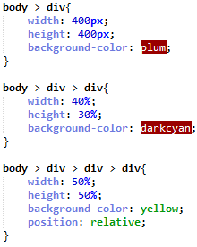
No difference in the behavior
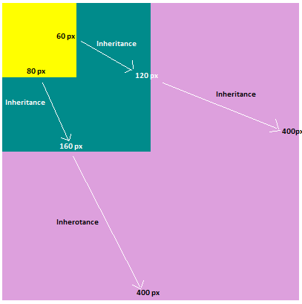

Case 3:
Below CSS styling has,
- Inner most div element of type position: absolute,
- Outer most div element of type position: relative.
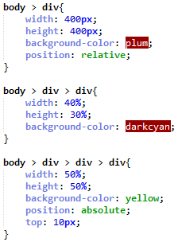
Behavior changes in inner most element. Dimensions are inherited from outer most div element.
